Railway Reservation System

Low Level Design (LLD)

**Table of Contents:**

1.0 Introduction *2*

2.0 Scope *2*

3.0 Document purpose *2*

4.0 System architecture and function *2*

5.0 Requirements *3*

6.0 ER Diagram *4*

7.0 Sequence Diagram *5*

8.0 Data Flow Diagram *6*

9.0 Database Schema *7*

10.0 Listing *8*

11.0 Update *8*

12.0 Cancel Reservation *9*

**1. Introduction:**

The railway lines and passengers have been increasing year by year in the country. With such a huge customer base, buying train tickets problem has been very prominent. The electronic commerce could solve the problem of railway ticketing. Introduced a new online ticketing system is not only technological innovation, but also will improve the railway services, to a certain extent, solve the difficult problem of railway ticketing by this online railway reservation system.

**2. Scope:**

A Software has to be developed for automating the manual Railway Reservation System.

RESERVE SEATS: Reservation form has to be filled by passenger. If seats are available entries like train name, number, destination are made.

VIEW RESERVATION STATUS: The user need to enter the PIN number printed on tickets

CANCEL RESERVATION: The clerk deletes the entry in the System and changes in the Reservation Status.

**3. Document Purpose:**

The main objective of the Project on Railway Management System is to manage the details of Trains, Timetable, Stations, Fare, Booking. It manages all the information about Trains, Customers, Booking, trains. The project is totally built at administrative end and thus only the administrator is guaranteed the access. The purpose of the project is to build an application program to reduce the manual work for managing the Trains, timetable, Customers, Stations. It tracks all the details about the Stations, Fare, Booking.

**4. System Architecture and function:**

A typical three-layer structure is used in the system: the database layer, the application service layer, the user interface layer.

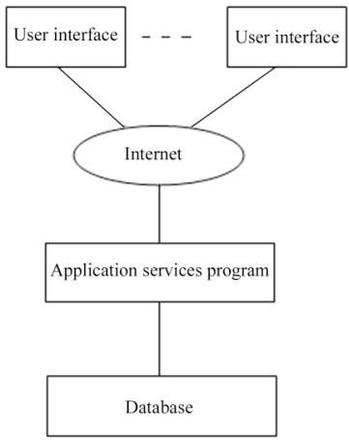

**5. Requirements:**

**User :**

For admin have services like registration Page, login page with basic details of user (like – UserName, email, phone no, password).

**Software Requirements:**

Back end: Visual Studio Code

Front end: Angular 7, CSS,HTML.

Database: SQL Server Management System

**Railway reservation:**

1. **For Admin**
2. **Registration Page** -> If user is new it will register by entering the details.
3. **Login ->**If the user is already register then it will login to system using credential like (Username, Password)**.**
4. Admin will verify the enter credential and allow user to login.
5. **For user:**
6. Login to system.
7. Check the details of train. (Like time, seats available etc).
8. If slot is available, then user will book the ticket.

**6. ER Diagram:**

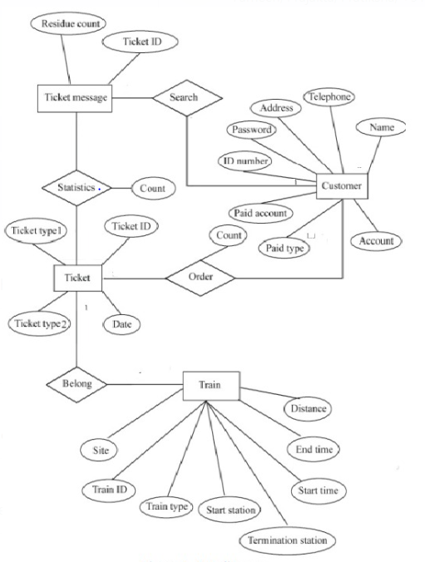

**7. Sequence Diagram:**

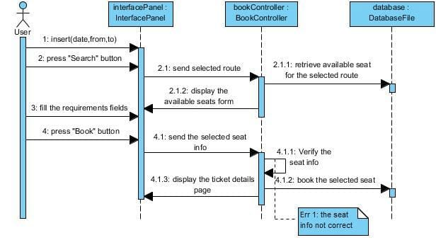

**8. Data Flow Diagram:**

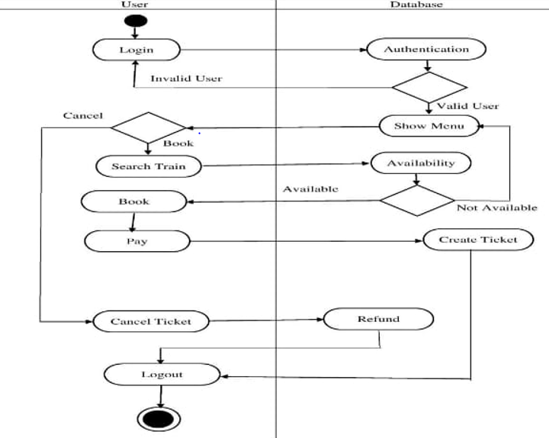

**9. Database Schema:**

**Registration Table:**

|  |  |  |
| --- | --- | --- |
| **Field Name** | **Data Type** | **Primary Key** |
| PassengerId | Int | Yes |
| Name | Char | No |
| Phone | Int | No |
| Gender | Varchar(50) | No |
| Email | Char | No |
| Password | Varchar(50) | No |
| Address | Char | No |
| Age | Int | No |

**Train Details:**

|  |  |  |
| --- | --- | --- |
| Field Name | Data Type | Primary Key |
| TrainId | Int | Yes |
| TrainType | Int | No |
| Start Station | Varchar(50) | No |
| Termination Station | Varchar(50) | No |
| Start Time | Int | No |
| End Time | Int | No |
| Distance | Int | No |

**Ticket Details:**

|  |  |  |
| --- | --- | --- |
| Field Name | Data Type | Primary Key |
| TicketId | Int | Yes |
| TicketType | Varchar(20) | No |
| TicketDate | Int | No |

**10. Listing**

**1**. Customer wants to get the customer details. Enters the id in parameter for which customer wants to see the details. Browser directs the request to Customer List API

2. Call reaches the API gateway.

3. API gateway does the routing and forwards the request to listCustomerHandler.handle this handle function calls the doProcess ()

4. doProcess () will call the listCustomerService.listCustomer() which calls the listCustomerRepository.listCustomer() to fetch the data from database.

5. It sends response body with HTTP Success response code to listCustomerHandler.

6. listCustomerHandler returns JSON Response

7. Success JSON response and HTTP status code 200 with corresponding success message.

**11. Update**

1. Log on to the website by providing the correct username and password. For directly updating the details, go to ‘Update Option’ and click on ‘Update’ link on the main menu bar.

2. All the details will be displayed like email id, phone no., address.

3. Select what needs to be updated and click on “Update”. Give the details which user want to update.

4. Select the email id of only those passengers who wants to change their emailid.

In this step user should give his/her emailid and confirm it so that they get all the details about ticket bookings to their mail.

5. By selecting phone no. option user can change his/her mobile no. and should give new number then click on update.

6. Confirmation pop up will be displayed after successful updation.

7. Similar to email id and phone no. user can update address.

8. The confirmation message will be sent to updated mobile number and emailid which was provided at the time of booking.

**12. Cancel Reservation:**

1. Log on to the website by providing the correct username and password. For directly cancelling the ticket, go to ‘My Transactions’ and click on ‘Booked Ticket History’ link on the main menu bar.

2. All the booked tickets will be displayed. Select the ticket which is to be cancelled and click on ‘Cancel Ticket”. Initiate the cancellation procedure by selecting the passengers to be cancelled

3. Select the names of only those passengers whose reservation has to be cancelled, in the case of partial cancellation of ticket. In case of partial cancellation, the passenger should get a fresh printout of the electronic reservation slip (ERS) for the passengers who are continuing their journey.

4. Select the check box before the passenger’s name and click on ‘Cancel Ticket’ option.

5. Confirmation pop up will be displayed. Select the ‘OK’ button to confirm the cancellation.

6. Upon successful cancellation, the cancellation amount deducted and the refund amount to be refunded will be displayed on the screen.

7. The confirmation message for cancellation will be sent on mobile number which was provided at the time of booking.

8. The confirmation mail for cancellation will be sent on email ID, which was registered with website User ID.

9. In case the ticket is partially cancelled, a fresh electronic reservation slip (ERS) needs to be carried by the passenger.